System Requirements Statement (SRS) –

Online Dairy World

Doc. Ref. : SRS_v0.4.doc

Version : 0.4

Status : Drafted

Created by : Rajashree Bhamare,Dhruti Patil,Supriya Bhinge,Aditya Waikar.

Date : 09-Jul-2023

1. Introduction 3

2. Functional Requirements 4

2.1 Admin Module 5

2.2 Supplier Module 11

2.3 Buyer Module 17

2.4 UseCaseDiagram ………………………………………………………………………………….

# Introduction

* This document explains the system requirements and scope for developing Online Dairy World System.
* Online Dairy World System could divide the three main parts Admin part, Supplier part, Buyer part.
* This document outlines the system requirements and scope for developing an online dairy products web application.

# Functional Requirements

The Account part of Online Dairy World System has three modules which are divided into processes described as below.

|  |  |  |
| --- | --- | --- |
| **No** | **BRS requirement ID** | **Description** |
| **2.1** | **Admin Module** | |
| **2.1.1** | **F1** | **Add all employees** |
| **2.1.2** | **F2** | **Update employees** |
| **2.1.3** | **F3** | **Delete Employees.** |
| **2.1.4** | **F4** | **Authenticate Supplier** |
| **2.1.5** | **F5** | **Update Supplier** |
| **2.1.6** | **F6** | **Delete Supplier** |
| **2.1.7** | **F7** | **Browse Products** |
| **2.1.8** | **F8** | **Handover Delivery to Delivery boy.** |
| **2.1.9** | **F9** | **Track Order Status** |
| **2.1.10** | **F10** | **Receive Payment from Supplier** |
| **2.2** | **Supplier Module** | |
| **2.2.1** | **F11** | **Registration and creation of Supplier’s profile** |
| **2.2.2** | **F12** | **Supplier Login** |
| **2.2.3** | **F13** | **Forgot Password and Change Password** |
| **2.2.4** | **F14** | **Publish Products for sale** |
| **2.2.5** | **F15** | **View Products.** |
| **2.2.6** | **F16** | **Update Product Information.** |
| **2.2.7** | **F17** | **Delete Product Information.** |
| **2.2.8** | **F18** | **Browse existing Product Price.** |
| **2.3 Buyer Module** | | |
| **2.3.1** | **F19** | **Registration and creation of buyer’s profile** |
| **2.3.2** | **F20** | **Forgot Password Process** |
| **2.3.3** | **F21** | **Change Password Process.** |
| **2.3.4** | **F22** | **Update Account Process.** |
| **2.3.5** | **F23** | **View Products.** |
| **2.3.6** | **F24** | **Add To Cart Products.** |
| **2.3.7** | **F25** | **Delete Products from Cart** |
| **2.3.8** | **F26** | **Make Payment** |
| **2.3.9** | **F27** | **Give Feedback.** |

## Admin Module:

## Administrator should be responsible for following activities.

1. **Add, Update, Delete Employees**:
   * Admin should be able to add new employees who will be responsible for delivering the product.
   * Admin should have the ability to update the details of existing employees, such as their name, contact information, etc.
   * Admin should be able to delete employees from the system if they are no longer associated with the organization.
2. **Authenticate, Update, Delete Suppliers**:
   * The admin should be able to authenticate suppliers before they are added to the system .
   * This functionality ensures that only authorized suppliers are included in the system, providing an extra layer of security and trust.
   * The admin should have the ability to update supplier details, including their name, contact information, and authentication credentials.
   * The admin should be able to delete suppliers from the system if they are no longer relevant or authorized.
3. **Browse Products:**
   * The admin should be able to browse through all the products available in the system.
   * This functionality allows the admin to view the product details, such as the name, description, price, and quantity.
4. **Handover Delivery to Delivery Boy:**
   * The admin should have the capability to assign the delivery of an order to a specific delivery boy.
   * This functionality enables the admin to select a delivery boy from the available employees and assign them to handle the delivery of a particular order.
5. **Track Order Status:**

* The Admin should be able to keep track of the status of all orders.
* This functionality allows the Admin to monitor the progress of orders, such as whether they are pending, in progress, or delivered**.**

1. **Receive Payment from Supplier:**

* The Admin should have the ability to receive payments from Supplier.
* This functionality enables the admin to record and manage payments made by Supplier for the products supplied.

**2.2 Supplier Module:**

* Farmers/Sweet Dealers are the suppliers of system who wants to sale the product.
* They should also able to view the market prices of products.

**2.2.1 Account Creation Process**

* Online Dairy World System compels to create the account before using it. So, System should provide the function which makes supplier creates new account.
* When supplier creates new account, the function demands three information described as below:

1. Login information.
2. Contact Details.
3. Security Credentials.

* **Login information**

The Login information consists of some items described as below.

1. User ID
2. Password
3. First Name
4. Last Name
5. E-mail address
   * All items are compulsory demanded.
   * User ID

* The User ID should be unique. If the User ID entered is case sensitive to other which is previously registered, the User ID should not be registered as an account.
  + Password
* The Password has constraints which makes the Password consists of more than or equal 8 and less than or equal 16 characteristics including characters described as below.

1. Numeric figure (at least one)
2. Capital alphabet (A-Z) (at least one)
3. Small alphabet (a-z) (at least one)
4. Special character (#, $, %, &, etc.) (at least one)

* The Password is masked by dummy characters. The re-entering Password is demanded.
* The Password must be encrypted in Online Dairy World System.
* **Contact Details**

The Contact Detail consists of some items described as below.

1. Permanent Address
2. Contact Phone No
   * All items are compulsory demanded.
   * Permanent Address

* Permanent Address should be filled.
* But only the villages/areas should be selected from options.
  + Contact Phone No
    - It has constraint which accepts the phone number exactly of 10 digits.
* **Security Credentials**

The Security Question information is needed when supplier lost their Password. This information consists of two items described as below.

1. Selected Question
2. Answer
   * All items are compulsory demanded.
   * Some questions which are difficult to answer for anyone else are prepared in advance.

E.g. which color do you like most?

* + A question should be selected from options by the supplier, and the Answer is registered by the supplier.
* Login information should be entered on one screen, and then supplier information and Security Question information should be entered on another screen.

**2.2.2 Login Process**

* Online Dairy World System always compels user authentication before using itself except when a new account is successfully created.
* The user authentication demands User ID and Password. The User ID and the Password should be checked in two ways.
  + First, The User ID and the Password should be existed and correct.
* If The User ID and the Password are not equal to what the user has registered, the user authentication cannot be provided.
  + User ID should be available.
* The Administrator can decide whether the User ID is available or suspended – Refer to the SRS of the Admin part.
* If supplier is rejected, user authentication is not provided for system user.
* The supplier account should alive as long as the duration decided by Admin or Supplier deletes his account
* Only when the two checks are successfully completed, Supplier can be placed on respected page.
* The “Supplier Home” provides some items described as below.

1. A trigger to logout
2. A trigger to update Account
3. A trigger to Change Password
4. A trigger to Search Product
5. A trigger to Publish Product for sale
6. A trigger to Update Product Information
7. A trigger to Delete Product
8. A trigger to Browse existing Market price of Products

**2.2.3 Forgot Password Process**

* When system user lost their Password, the recovery method should be provided by Online Dairy World system.

The recovery method is described as below.

* + First, System user enters their User ID for Online Dairy World System.
  + Next, System demands the Answer which has been registered since when the Account was created.
  + Only when the Answer is correct, Supplier get the new password by E-mail, which has been registered since when the Account was created.
  + The new password is automatically generated by System.
* Of course, the new Password should consist of more than or equal 8 and less than or equal 16 characters including at least a numeric figure, a capital alphabet, a small alphabet and a special character.
* Hence, Supplier will be able to login to the System.
  + Then, if Supplier wants to change the Password, he/she can set the new password manually.
* If the Answer is not correct, otherwise, the correct Answer is demanded for user again.
  + In that case, Of course, supplier couldn’t get the new Password.

**2.2.4 Change Password Process**

* When supplier wants to change their Password, the measure should be provided by Online Dairy World System.
* Therefore, System should provide the function which is available after getting the Supplier’s authentication.
* The function demands the current Password and the new Password.
  + Of course, the new Password should consist of more than or equal 8 and less than or equal 16 characteristics including at least a numeric figure, a capital alphabet, a small alphabet, and a special character.
  + The current Password and the new Password are masked by using dummy characters.
  + The new Password is demanded to enter twice to avoid a typing error.
* Only when the current Password is correct, Supplier could change their Password.
* When the current Password is changed into new Password, system compels user authentication again.

**2.2.5 Update Account Process**

* System should provide the function which makes the account updated for Supplier.
* The information Supplier could update is described below.

1. Login information
2. User information
3. Security Question Information

* The Login information

The updatable items as described below.

1. First Name
2. Last Name
3. E-mail address
   * All items are compulsory demanded, but updating is optional.

* The User information

The updatable items as described below.

1. User Name
2. User Phone No
3. E-mail address
4. Permanent address
   * All items are compulsory demanded, but updating is optional.

* The Security Question information

The updatable items as described below.

1. Selected Question
2. Answer
   * All items are compulsory demanded, but updating is optional.

**2.2.6 View Products**

* Search conditions are described as below.

1. Product category
2. Price range

### 2.2.7 Publish product for sale

* Publish products requirements are described as below.

1. Product category
2. Price
3. Product name
4. Quantity
5. Photos

### 2.2.8 Update product information

* After publishing the Product the Supplier can only update following contents.

1. Product quantity
2. Product price.

### 2.2.9 Delete product information

• After publishing if Suppliers want to remove some products then Supplier can delete the Product.

### 2.2.10 Browse existing Product Price

• Supplier could see the information of existing products.

**2.2.11 Receive Payment from Buyer**

* The Supplier should have the ability to receive payment from Buyer.

**2.3 Buyer Module**

* Buyer is user of the system who can buy the products.
* Buyer should be able to view the products, add the products to cart, place an order , cancel order, make payment. Also, Buyer should get notified when order gets placed and when the order is received.
* Buyer should be able give feedback about received product.

**2.3.1 Registration and creation of Buyer’s profile**

* Online Dairy World System always compels user authentication before using itself except when a new account is successfully created.
* When Buyer creates new account, the function demands three information described as below:
  + 1. Login information.
    2. Contact Details.
    3. Security Credentials.
* **Login information**

The Login information consists of some items described as below.

1. User ID
2. Password
3. First Name
4. Last Name
5. E-mail address
   * All items are compulsory demanded.
   * User ID

* The User ID should be unique. If the User ID entered is case sensitive to other which is previously registered, the User ID should not be registered as an account.
  + Password
* The Password has constraints which makes the Password consists of more than or equal 8 and less than or equal 16 characteristics including characters described as below.
* Numeric figure (at least one)
* Capital alphabet (A-Z) (at least one)
* Small alphabet (a-z) (at least one)
* Special character (#, $, %, &, etc.) (at least one)
* The Password is masked by dummy characters. The re-entering Password is demanded.
* The Password must be encrypted in Online Dairy World System.
* **Contact Details**

The Contact Detail consists of some items described as below.

1. Permanent Address
2. Contact Phone No
   * All items are compulsory demanded.
   * Permanent Address

* Permanent Address should be filled.
* But only the villages/areas should be selected from options.
  + Contact Phone No
* It has constraint which accepts the Phone No exactly of 10 digits.
* **Security Credentials**

The Security Question information is needed when Buyer lost their Password. This information consists of two items described as below.

1. Selected Question
2. Answer
   * All items are compulsory demanded.
   * Some questions which are difficult to answer for anyone else are prepared in advance.

E.g. which color do you like most?

* + A question should be selected from options by the Buyer, and the Answer is registered by the Buyer.
* Login information should be entered on one screen, and then Buyer information and Security Question information should be entered on another screen.

**2.3.1 Login Process**

* The Buyer’s authentication demands User ID and Password. The User ID and the Password should be checked in two ways.
  + First, the User ID and the Password should be existed and correct.
* If The User ID and the Password are not equal to what the user has registered, the user authentication cannot be provided.
  + User ID should be available.
* The Administrator can decide whether the User ID is available or suspended – Refer to the SRS of the Admin part.
* The Buyer’s account is alive as long as the Buyer does not deletes his/her account
* Only when the two checks are successfully completed, Buyer can be placed on respected page.
* The “Buyer Home” provides some items described as below.

1. A trigger to Logout.
2. A trigger to Update Account.
3. A trigger to Change Password.
4. A trigger to View Product.
5. A trigger to Delete Account.
6. A trigger to Shopping Cart.
7. A trigger to Give Feedback.

**2.3.2 Forgot Password Process**

* When system user lost their Password, the recovery method should be provided by Online Dairy World system.

The recovery method is described as below.

* + First, System user enters their User ID for Online Dairy World System.
  + Next, System demands the answer which has been registered since when the Account was created.
  + Only when the answer is correct, Buyer get the new password by E-mail which also has been registered since when the Account was created.
  + The new password is automatically generated by System.
* Of course, the new password should consist of more than or equal 8 and less than or equal 16 characteristics including at least a numeric figure, a capital alphabet, a small alphabet, and a special character.
* Hence, Buyer will be able to login to the System.
  + Then, if Buyer wants to change the Password, he/she can set the new Password manually.
* If the Answer is not correct, otherwise, the correct Answer is demanded for user again.
  + In that case, of course, Buyer couldn’t get the new Password.

**2.3.3 Change Password Process**

* When Buyer wants to change their Password, the measure should be provided by Online Dairy World System.
* Therefore, System should provide the function which is available after getting the supplier authentication.
* The function demands the current Password and the new Password.
  + Of course, the new Password should consist of more than or equal 8 and less than or equal 16 characteristics including at least a numeric figure, a capital alphabet, a small alphabet, and a special character.
  + The current password and the new Password are masked by using dummy characters.
  + The new Password is demanded to enter twice to avoid a typing error.
* Only when the current Password is correct, Buyer could change their Password.
* When the current Password is changed into new Password, system compels user authentication again.

**2.3.4 Update Account Process**

* System should provide the function which makes the account updated for Buyer
* The information of Buyer could update as described below.

1. Login information
2. User information
3. Security Question Information

* The Login information

The updatable items as described below.

1. First Name
2. Last Name
3. E-mail address
   * All items are compulsory demanded, but updating is optional.

* The User information

The updatable items as described below.

1. User Name
2. User Phone No
3. E-mail address
4. Permanent address
   * All items are compulsory demanded, but updating is optional.

* The Security Question information

The updatable items as described below.

* + - 1. Selected Question
      2. Answer
  + All items are compulsory demanded, but updating is optional.

**2.3.5 View Products**

* Search conditions are described as below.
  + - 1. Product category
      2. Price range.

**2.3.6 Add Products to Cart**

* Add to Cart functionality includes an "Add to Cart" button or clickable element adjacent to each displayed product. This button allows the buyer to add the respective product to their shopping cart.

**2.3.7 Delete Products from Cart**

* Delete products from Cart functionality includes that when the Buyer clicks the "Delete" button for a particular item, handle the action by performing the following steps:
  1. Identify the item: Determine the unique identifier or index associated with the item to be deleted. This identifier will help locate the item in the cart.
  2. Remove the item from the cart: Using the identifier obtained in the previous step, remove the corresponding item from the shopping cart. This can be done by updating the cart object or data structure and removing the selected item.
  3. Update the cart display: Reflect the changes made to the cart in the buyer module's interface. Remove the deleted item from the displayed cart view, ensuring that it is no longer visible.
  4. Update cart total: Recalculate the total cost or any other relevant calculations associated with the cart to reflect the removal of the deleted item.

**2.3.9. Make Payment**

* Display the total amount: Show the calculated total amount to the Buyer in the Buyer module's interface, indicating the amount they need to pay.
* Provide payment options: Implement various payment options that the buyer can choose from, such as credit card, PayPal, bank transfer, or any other relevant methods.

**2.3.10 Give Feedback**

* The Feedback Description feature should be linked to specific orders, enabling Buyers to provide feedback on individual purchases.
* Buyers should be able to access their order history and select the relevant order for providing feedback.
* The System should display order details, including the products purchased, delivery date, and any other relevant information to assist buyers in providing accurate feedback.

**2.5 Use Case Diagram**

**Admin:**

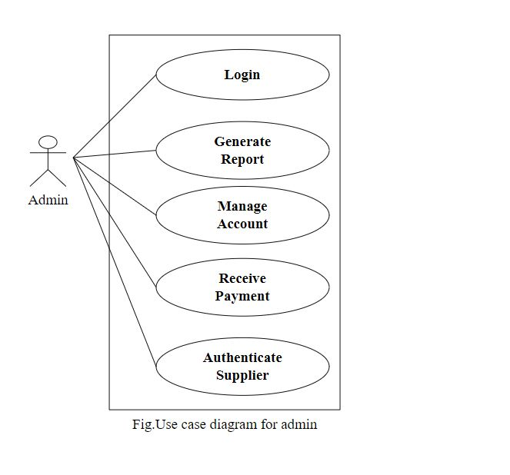

1. In Admin use case diagram Admin is the Actor.
2. Admin can handle following use cases:
3. Login
4. Report Generation
5. Manage account
6. Receive payment
7. Authenticate Supplier

**Supplier:**

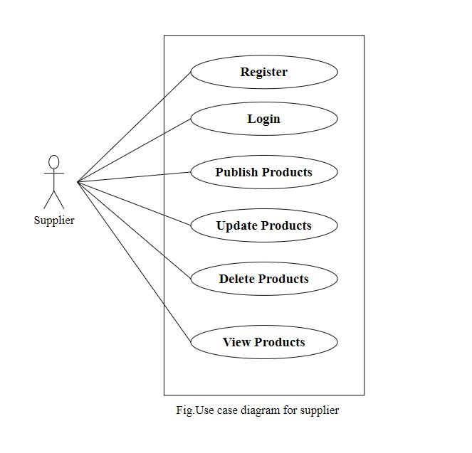

1. In Supplier use case diagram Supplier is the Actor
2. Supplier can handle following use cases.
3. Register in the System.
4. Login after successful registration
5. Can Publish his/her products on the system.
6. Update product details.
7. Delete Products.
8. View Products.

**Buyer:**

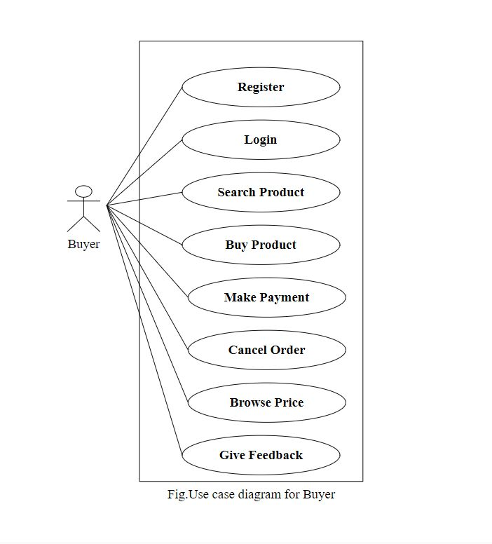

1. In Buyer use case diagram Buyer is the Actor.
2. Buyer can handle following use cases:
3. Buyer can Register in the system
4. Login
5. Search products.
6. Make payment.
7. Cancel order
8. Browse price.
9. Give Feedback.